Relationships & Sexuality
Education Policy

Mother of Divine Grace N.S.

Approved by

Board of Management on

Relationships and Sexuality Education Policy

Mother of Divine Grace N.S.

Definition of Relationships and Sexuality Education (RSE)
Relationships & Sexuality Education (RSE) as part of Social Personal and Health Education aims to help children learn at home and in school about their own development and about their friendships and relationships with others. This work is based on developing a good self-image, promoting respect for themselves and others and providing them with appropriate information.

Our RSE programme will be taught in line with the Flourish Programme (See Appendix 2)

RSE aims to provide opportunities for children and young people to learn about relationships and sexuality in ways that help them think and act in a moral, caring and responsible way.

Relationship to SPHE
All of the RSE will be delivered within the context of Social Personal and Health Education (SPHE) which is timetabled on our Curriculum. SPHE is spiral, developmental in nature and age appropriate in content and methodology. The RSE programme is designed to follow this principle and pattern.

Apart from the specific lessons of RSE, SPHE covers other areas which would be pertinent to the development of a healthy attitude to sexuality in oneself and one’s relationship with others. SPHE deals with many issues such as self-esteem, assertiveness, communication and decision making skills – all of which can contribute to the effectiveness of the RSE programme.

RSE specific context will be covered in the Strand Units; taking care of my body, growing and changing and safety and protection.

The aims of RSE
- To enhance the personal development, self-esteem and well-being of each child.
- To foster an understanding of, and a healthy attitude to, human sexuality and relationships in a moral, spiritual and social framework.
- To help the child understand and develop healthy friendship and relationships.
- To enable the child to acquire and understanding of, and respect for, human love, sexual intercourse and reproduction.
- To develop and promote in the child a sense of wonder and awe at the process of birth and new life.
- To enable the child to be comfortable with the sexuality of oneself and others while growing and developing.
- The school’s function is to provide a general education about sexual matters and issues and not to offer individual advice, information or counselling on aspects of sexual behaviour or contraception.

Class Specific Content
The RSE programme is divided into two main parts:
1)The general programme which contains content covered through SPHE strands and strand units and compliment the aims and objectives of RSE ie. Friendship, Self-Identity, Family,q` Self Esteem, Growing Up
2) The second section will deal with any sensitive/specific content covered through RSE strands and strand units. See Appendix 1 + 2

The acquisition of appropriate language in RSE is crucially important to enable children to communicate confidently about themselves, their sexuality and their relationships. Not being familiar with the biological terms for the body can put children at a disadvantage.

Therefore we will give the correct and appropriate language as outlined in RSE Resource materials. See Appendix 1 and Appendix 2 for more information on sensitive content/topics in bold

Junior/Senior Infants
- The terms ‘womb’ and ‘vagina’ will be taught,
- The term ‘penis’ will be taught as the obvious physical difference between boy/girl,
- The term ‘breast feeding’ may be used in conversation as means for feeding a baby.

1st/2nd Classes
- Penis, vagina womb and urethra will be taught/revised in terms of passing urine.
- Teachers will teach that baby is in the womb for 9 months and may be breast or bottle fed.

3rd/4th Classes
- Developing foetus and menstruation.
- Menstruation for 4th class.
- Nutrition in the womb and the function of the umbilical cord.
- Good nutrition – Mother needs to eat healthily to look after the baby.
- Taking care with medicines, alcohol and smoky environment – mother should avoid all of these as some of the medicine, alcohol and smoke could travel through the umbilical cord to the baby.
- Ways that family members can help – Helping a mother who is expecting.
- Travel/Work – Letting pregnant women have a seat on public transport.
- Exercise – Mother needs to stay healthy and exercise.
- Medical checkups – Mother who is expecting goes to the doctor regularly.
- After 9 months the baby is born.

Most common question: How did the baby get out of the Mammy?

Answer to be given: Through an opening in the Mammy’s body called the vagina.

5th/6th Classes

5th Class
- Different kinds of friends
- Feelings and Emotions – psychological and emotional changes during puberty
- My body grows and changes – Puberty, physical changes in girls and boys, sperm, semen, testicles, scrotum, erection, wed dreams, female reproduction, ovaries, fallopian tubes, womb/uterus, cervix, menstruation
- The wonder of new life – how the sperm and egg meet
- Caring for new life

6th Class
- Puberty
- Different kinds of love
- Keeping safe and healthy – virus, bacteria and infections
- Feelings and emotions – psychological and emotional changes during puberty
- Growing and changing – what age must I be…
- Relationships and new life – reproduction and sexual intercourse. This will be taught using the language outlines in DES RSE Resource Materials for 5th/6th classes.
- Caring for new life

Special Education Needs

All lessons will be differentiated appropriately to cater for the individual needs of children.

Both the age and stage of the child will be considered. Our SEN Policy will be followed.

Explicit Questions (See Appendix 4)
- When deciding whether to answer questions the teacher should consider the age and readiness of the students, the RSE programme content, the ethos of the school and the RSE policy.
- Teachers will only answer questions relating to the relevant part of the curriculum for that class level.
- The ‘Question Box’ should be used (See Appendix 3)
- Questions do not have to be answered straight away
- No personal questions of the teacher
- Teacher should be mindful of their reaction to questions

On occasion, children may ask questions that are not age appropriate. Teachers may choose to say that it is not appropriate to deal with that question at this time or may suggest that the child ask their parents.

If a teacher becomes concerned about a matter that has been raised he/she should seek advice from the SPHE Co-ordinator or the Designated Liaison Person (DLP).

Confidentiality:
It is school policy that in circumstances where a pupil is considered at some risk of any type of abuse or in breach of the law, the teacher must refer this immediately to the DLP. The DLP will decide whether to inform the parents and/or appropriate authorities and may arrange for counselling.

The following is also school policy:

- Teachers must not promise absolute confidentiality
- Pupils must be made aware that any incident may be conveyed to the DLP and possible to parents if the Principal decides that it is in the best interests of the pupil to notify parents
- Teachers must use their professional judgement to decide whether confidence can be maintained having heard the information
- Teachers must indicate clearly to pupils when the content of a conversation can no longer be kept confidential – the pupil can then decide whether to proceed or not.
- Any action taken should fully comply with our Child Protection Policy.

The Child Protection Guidelines for Primary schools state in 4.1.1 and 4.2.1.
- 4.1.1 If a member of staff receives an allegation or has a suspicion that a child may have been abused, or is being abused, or is at risk of abuse he/she should, without delay, report the matter to the Designated Liaison Person in that school. A written record of the report should be made and placed in a secure location by the Designated Liaison Person. The need for confidentiality at all times, as previously referred to in Chapter 1 Paragraph 1.2 of these guidelines, should be borne in mind. The supports of the school should continue to be made available to the child.

Parental involvement should exist in terms of language used and parents should see this policy.
- All content objectives will be covered by the time the children leave 6th class.
- Parents will be made aware of the RSE topics that will be covered each school year and the ethos within which they will be delivered. See sample letter Appendix 3 Any parent who has concerns should discuss them with the class teacher and alternative arrangements may be made if deemed necessary. A parent who asks to have his/her child withdrawn from specific objectives should do so in writing in advance of the lessons.
- Teachers will only teach the topics laid down for the class and will answer only those questions on the programme for that year.
- In the event of a teachers discomfort with a particular topic, that teacher should make an arrangement with a colleague to support him/her.
- A suitable guest speaker (i.e. Accord facilitator) may be invited into deliver the contents of the programme to 5th/6th class. All information delivered by such a speaker will be informed by the content objectives of the SPHE curriculum. A teacher will remain in the classroom at all times during the guest speaker’s presentation, the speaker does not replace the teacher. They act as a support.
- Everyone has a right to privacy. Teachers will not answer personal questions about themselves nor require the child to give information of a personal nature which they do not wish to share.

Role of the Board of Management
The Board of Management will support the teaching of RSE through ensuring the adequate supply of relevant course material and through the provision of sufficient training. Also, the BOM are active in the development and review of this policy.

Ratification and Communication

A copy of the policy will be made available to parents on request.

This policy was presented to the Board of Management for approval on: 03/10/23

Signed: ________________________ Chairperson Board of Management Date __________

Signed: ________________________ Principal Date __________

Review The policy will be reviewed on an ongoing basis. All parents will be informed of any amendments from this review.

APPENDIX 1
(Sensitive content)

Topics covered up to 2nd include:  • Keeping safe  • Bodily changes from birth (birth-9)  • Making age-appropriate choices  • Appreciating the variety of family types and the variety of family life that exists in our school and community  • Recognising and expressing feelings  • Self-care, hygiene, diet, exercise and sleep • Expressing opinions and listening to others • Naming the parts of the male/ female body using appropriate anatomical terms (Junior/ Senior Infants)  • Naming the parts of the male/ female body using appropriate anatomical terms and identify some of their functions (1st/2nd). | Topics from 3rd to 6th include:  • Bodily changes  • Healthy eating, personal hygiene and exercise  • Keeping safe  • Expressing feelings  • Appreciating the variety of family types within our school and community and how these family relationships shape us  • Making healthy and responsible decisions • Forming friendships  • Discuss the stages and sequence of development of the human baby in the womb(3rd, 4th class)  • Introduction to puberty and changes (3rd, 4th, 5th and 6th class)  • Changes that occur in boys and girls with the onset of puberty ( 5th and 6th Class)  • Reproductive system of male/female adults (5th and 6th class)  • Understanding sexual intercourse, conception and birth (5th, 6th class).

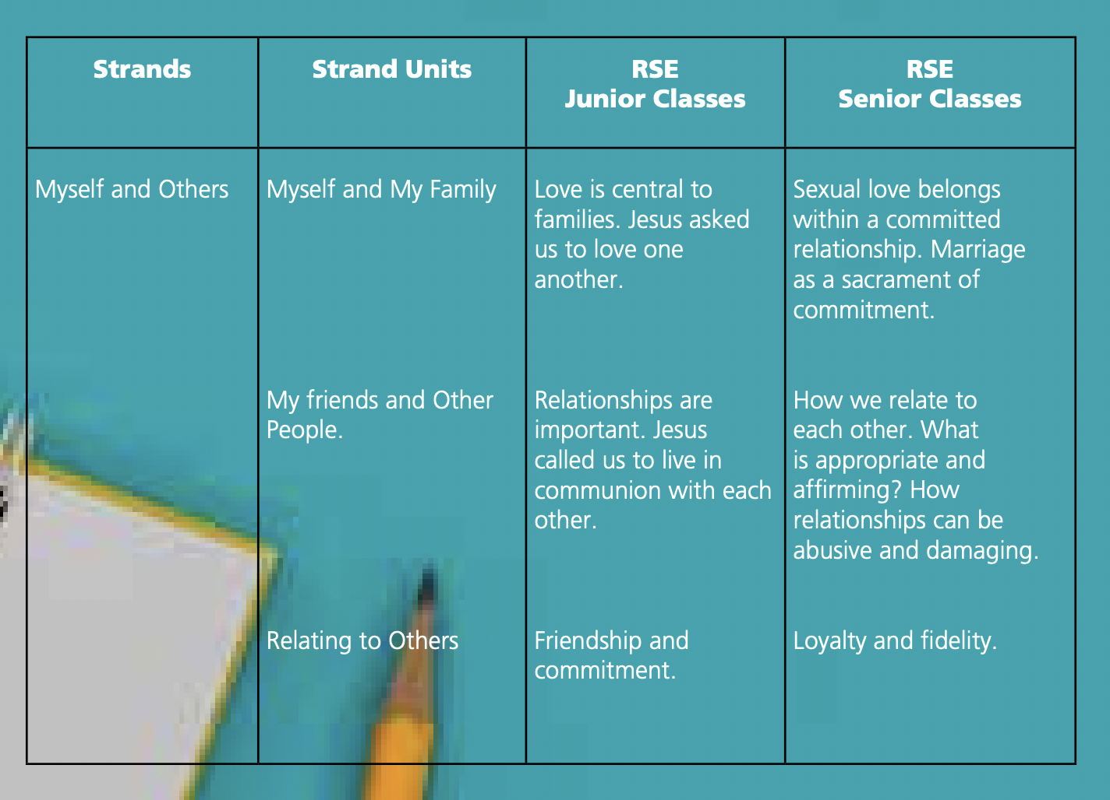
Appendix 2

Appendix 2

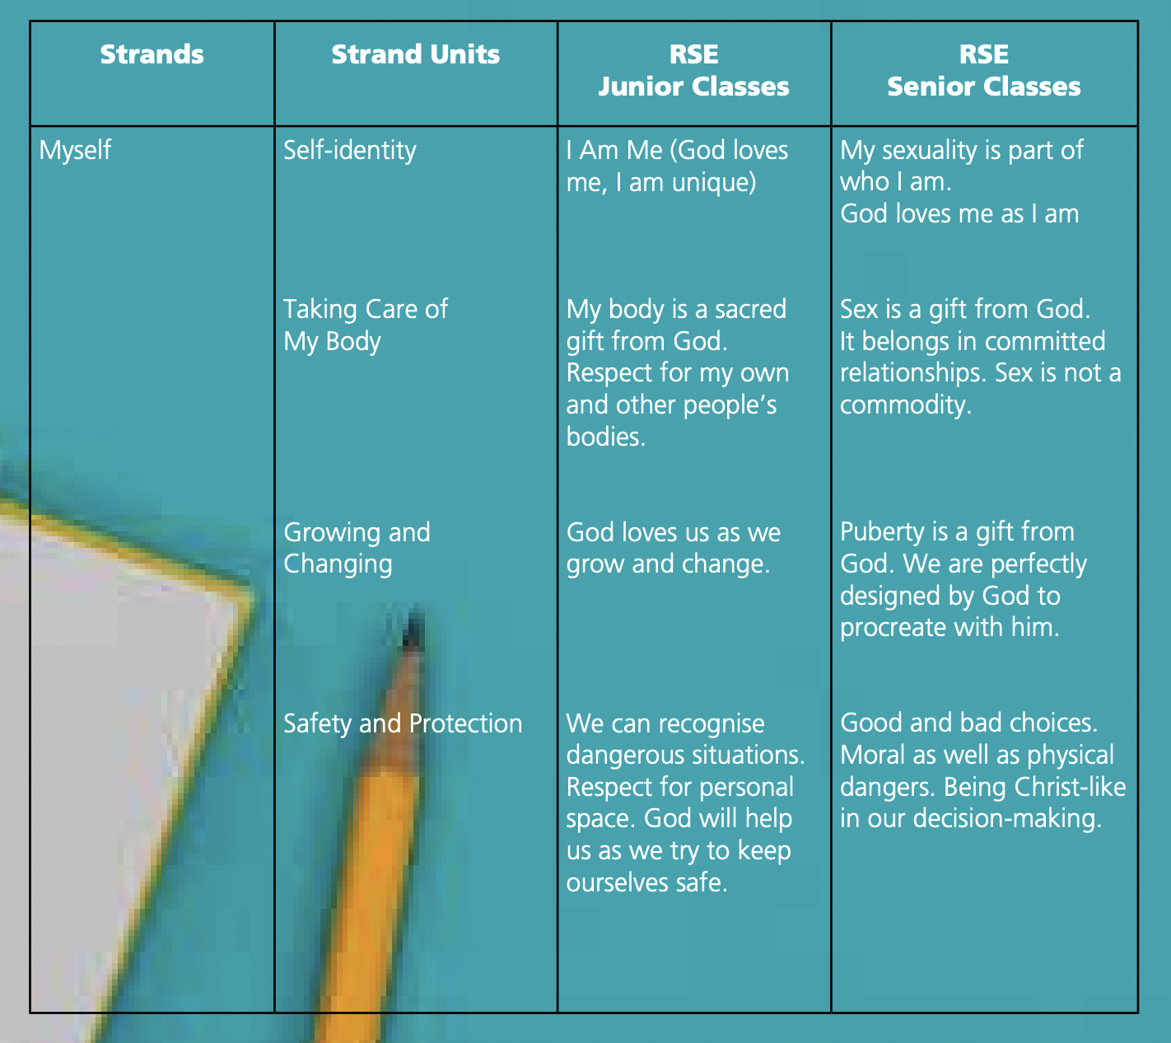

Appendix 3

Dear…
Relationships and Sexuality education is an integral part of the S.P.H.E programme. The sensitive elements of the Relationships and Sexuality education programme are covered under the Strand Units, ‘Growing and Changing’ and ‘Taking Care of my Body’. We will be completing these Strand Units with all class levels in the forthcoming weeks.

Topics covered up to 2nd include:  • Keeping Safe  • Bodily changes from birth (birth-9)  • Making age appropriate choices  • Appreciating the variety of family types and an variety of family life that exists in our school and community  • Recognising and expressing feelings  • Self-care, hygiene, diet, exercise and sleep  • Expressing opinions and listening to others • Naming the parts of the male/ female body using appropriate anatomical terms (Junior/ Senior Infants) The Language at taught at this level will be…..  • Naming the parts of the male/ female body using appropriate anatomical terms and identify some of their functions (1st/2nd) ) The Language at taught at this level will be….. Derived from the Flourish and Stay Safe Programmes. | Topics from 3rd to 6th include:  • Bodily changes  • Healthy eating, personal hygiene, exercise  • Keeping Safe  • Expressing Feelings  • Appreciating the variety of family types within our school and community and how we these family relationships shape us  • Making healthy and responsible decisions  • Forming Friendships  • Discuss the stages and sequence of development of the human baby in the womb(3rd, 4th class)  • Introduction to puberty and changes (3rd, 4th, 5th and 6th class)  • Changes that occur in boys and girls with the onset of puberty ( 5th and 6th Class) ) The Language at taught at this level will be…..  • Reproductive system of male/female adults (5th and 6th class) The Language at taught at this level will be…..  • Understanding sexual intercourse, conception and birth (5th, 6th class ) The Language taught at this level will be…..  Derived from the Flourish and Stay Safe Programmes.

The class teacher will send home appropriate home school links pages from the Relationships and Sexuality manual which outline the material that will be covered in class and encourage further discussion on the topics at home.

If you have any questions, please make an appointment to see the class teacher.

Yours sincerely,

Appendix 4

Questions
Staff should not invalidate questions but use limits.
The main aim of talk and discussion is to create an atmosphere where children feel comfortable to ask important questions and that the relationship fostered in these sessions is open, controlled and safe for all pupils. While you may not be able to answer all questions, your hope is that children will not be put off seeking answers in the school setting but will talk to their parents and ask the questions again at different stages of schooling or education, and are not put off because they perceived the topics or questions to be embarrassing

We use some simple principles when fostering discussion and questioning
- No personal questions of the teacher
- The Question Box will be availed of by the children
- The teacher will be mindful of their reaction to any questions
- Questions do not have to be answered straight away

Sample responses;
• I’ll do my best to answer your questions, but I may not be able to answer all of them
• That’s something you’ll learn about as you get older
• Is that something you could talk to your parents / guardians / family about?
• We agreed in our contract that we wouldn’t ask anyone personal questions
• Somebody asked a question and the language they used was slang language, what they meant to ask was….
• A question was asked, and we cannot talk about that particular topic, but I think that question was about.

For older children a ‘question box’ will be used as part of a structured RSE lesson. Teachers can follow up on the written questions at a later date, thus allowing time to prepare suitable answers, consult with colleagues, etc.

Staff should not invalidate questions but use limits. The main aim of talk and discussion is to create an atmosphere where children feel comfortable to ask important questions and that the relationship fostered in these sessions is open, controlled and safe for all pupils. While you may not be able to answer all questions, your hope is that children will not be put off seeking answers in the school setting but will talk to their parents and ask the questions again at different stages of schooling or education, and are not put off because they perceived the topics or questions be embarrassing.

Appendix 4 continued..

Question Box
During the delivery of each section of the sensitive lessons– children will be encouraged to place their questions into a box in the classroom. These questions will then be monitored and screened with the teacher answering the questions the following week taking into account the following:
- Questions arising from lesson content will be answered in an age-appropriate manner
- The class teacher cannot answer questions which do not relate to the particular curriculum objectives for a class
- Pupils will be informed if a question/issue is not on the programme and they will be advised to talk with their parents
- Teachers may exercise discretion to contact parents themselves if they feel that a question is very inappropriate or needs to be communicated with home because of other reasons
- No personal questions will be answered, and children will be reminded not to share personal information about their families or others – but can share with teacher after the lessons.

If issues arise which might be seen to contravene Children First Guidelines, the teacher will notify the Designated Liaison Person in the school.

